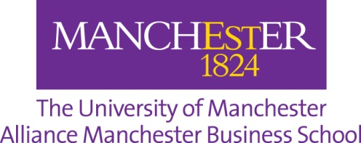

Application Form – Social Responsibility Scholarships – 2023 Entry
Application Deadline: 15th September 2023

Section 1: Personal details

Please complete all fields
First name / Given name
Surname / Family name
UCAS Personal ID # (10 digits)
University of Manchester ID # (7 digits)
Preferred email address
Contact telephone no

Section 2: Eligibility criteria

Please note that to be eligible to apply for this scholarship your results must equate to AAA at A-level (or above) – please contact our admissions team at ugadmissions.ambs@manchester.ac.uk if you are unsure as to whether your results meet this criteria before submitting your application

Please confirm your fee status as Home or International/EU (students classified as overseas for tuition fee purposes) | Home / International/EU (delete as appropriate)
Please confirm all level 3 qualifications completed and results achieved | e.g. AAA at A-level / AAA in the INTO International Foundation Year

Continues on the next page
Section 3: Statement of application

Your written application should consist of two parts with about 1,000 words for each part.

In the first part, please outline your previous personal social responsibility (SR) involvement in, for example, community-based project, volunteering opportunities and/or fundraising activities, and explain how they are linked to the United Nations Sustainable Development Goals (SDGs).

In the second part, please explain how you could further develop yourself and help developing other students in the school and university to become socially responsible graduates (please also include your understanding of the key attributes of “socially responsible graduates”).

